New Peace Banner for International Women’s Day 2022
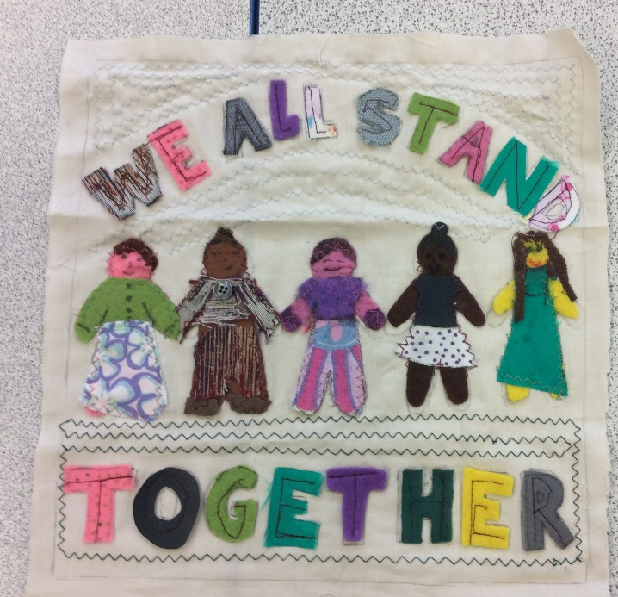
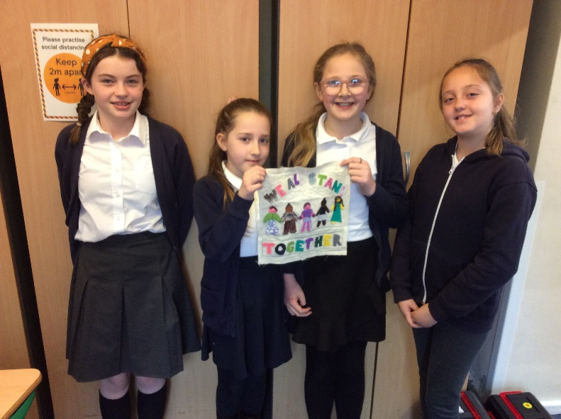
Some of year 5 girls helped make a section for the new peace banner that will be displayed in Bradford Peace Museum. The theme of the banner is Break the Bias and is inspired by the women of Greenham Common who defied expectations at the time to stand up for what they believed in. The design of our section has women of different backgrounds standing togehter demanding equality and fighting injustice and prejudice.

