Where to go for more information

Contact the school
If you have any questions about the support your child is
receiving, or about SEND more generally, please speak to your
child’s class teacher or our SENCo, Mrs Angela May.

See our website
The school’s SEN policy and Information Report set out more detailed information about the support available for children with SEN and disabilities. You can access this information on our school website: www.kirkstall-st-stephens.leeds.sch.uk

External links
The government’s SEND Code of Practice and a related guide for parents have more information about the topics outlined in this leaflet:
` | SEND support at  Kirkstall St  Stephen’s Primary  School
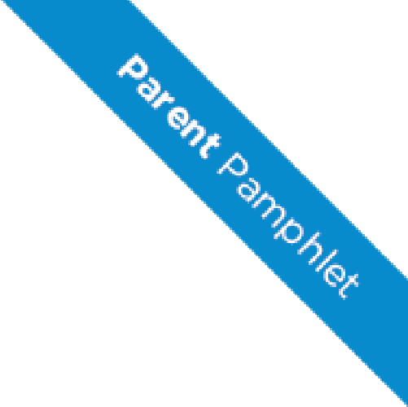
- SEND Code of Practice: 0 to 25 years, GOV.UK – DfE https://www.gov.uk/government/uploads/system/uploads/attachment_ data/file/398815/SEND_Code_of_Practice_January_2015.pdf

- SEND: a guide for parents and carers, GOV.UK – DfE
https://www.gov.uk/government/uploads/system/uploads/attachment_ data/file/417435/Special_educational_needs_and_disabilites_guide_for_ parents_and_carers.pdf

Tel: 0113 3821960
Email: angela.may@kirkstallss.net

What is SEN?
Some children find learning more challenging than others and may need extra support to achieve their full potential. For example, they might have difficulty with:
- Expressing themselves
- Interacting with others
- Reading, writing and maths
- Following lessons
- Controlling their emotions
- Sensory or physical mobility

These difficulties can be barriers to learning. At KSS we assess all children to identify their strengths and needs and how they can best be supported.
Children who need extra help with their learning may receive additional support under one of the following categories:
- SEN support
- An EHC plan
What is SEN support?
SEN support describes the additional help that assists children to access the curriculum.
This might include:
- Extra help in the classroom
- Small group or one-to-one learning
- Support from specialists such as speech and language therapists
We will always work with parents when agreeing what support to provide and what it is expected to achieve.

What are EHC plans?
If your child has more complex needs, he or she might be assessed for an Education, Health and Care plan. An EHC plan is a legal document which describes a child or young person’s special educational needs, the support they need, and the outcomes they would like to achieve. An EHC plan can only be issued after a child or young person has gone through the process of an Education, Health and Care needs assessment.
We use the ‘wave’ system to describe the type of support each child is receiving:
WAVE 1  High quality, differentiated teaching  For all children |  | WAVE 2  High quality teaching plus extra short-term support  For children making slower progress |  | WAVE 3  SEN support: additional long-term, individualised support  For children still making less progress than their classmates |  | WAVE 4  EHC plan  For children with more complex needs

FAQs
How will the school decide what type of support my child receives?
Every child’s needs are different, and may change over time.
We carefully assess each child’s needs to identify which support suits him/her best. We also speak to the pupil and their parents/carers about their needs and possible provision.
We regularly review the support every child receives to see what is working and what isn’t, and incorporate your views on this too.
How do I know if my child needs SEN support?
If your child is not making expected progress for his/her year group, he/she may need SEN support. However, low attainment is not an indicator of SEN.
We will always discuss your child’s needs with you before placing him/her on SEN support.
What if I think my child needs further support?
Please speak to your child’s class teacher or the SENCo, Mrs Angela May.

