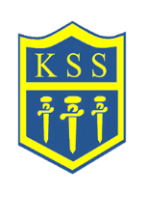

Assessments 2023, 2024 & 2025
KSS compared to Leeds and National schools
Early Years Foundation Stage
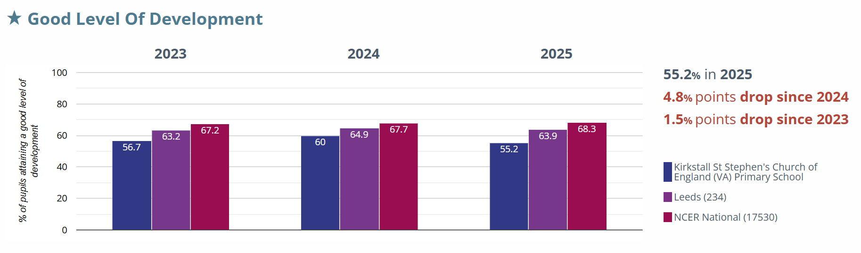
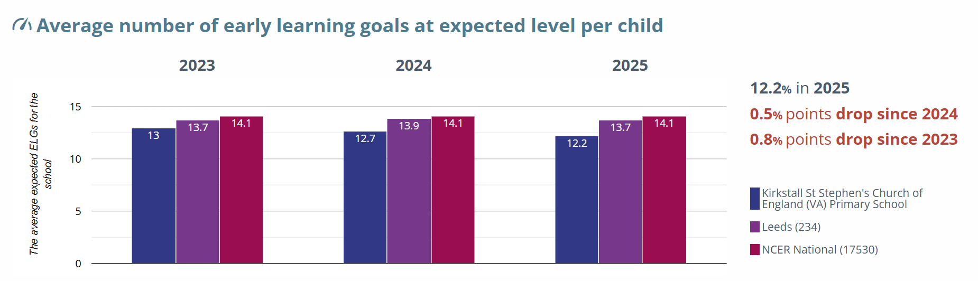
Phonics
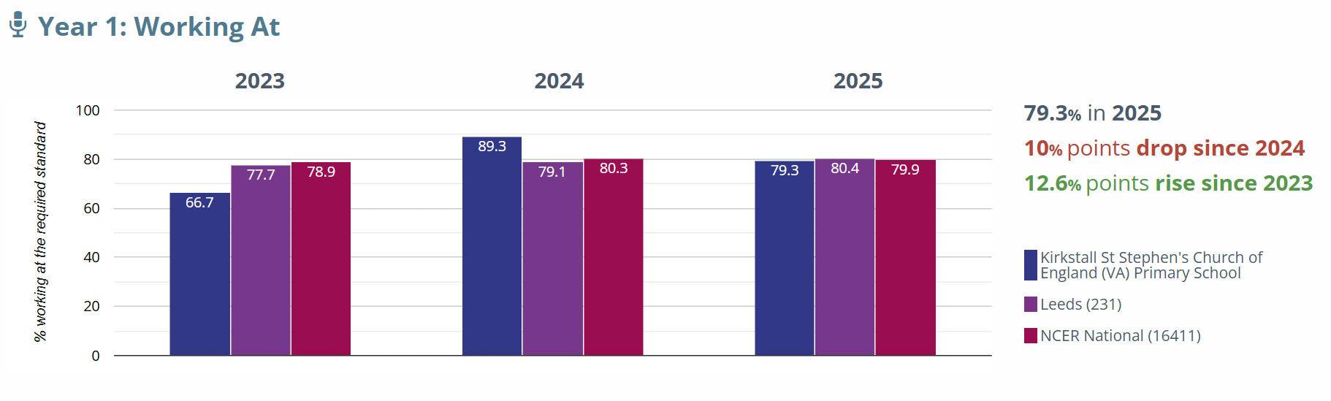

KS2 Assessments
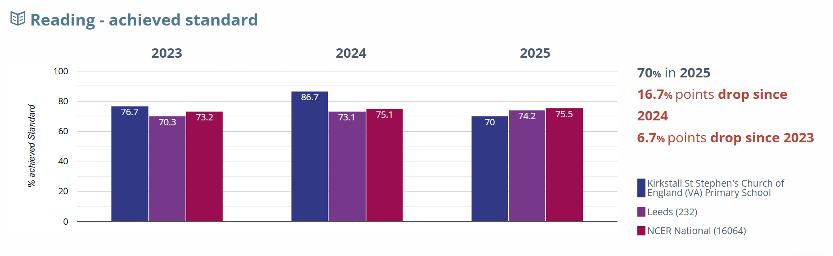
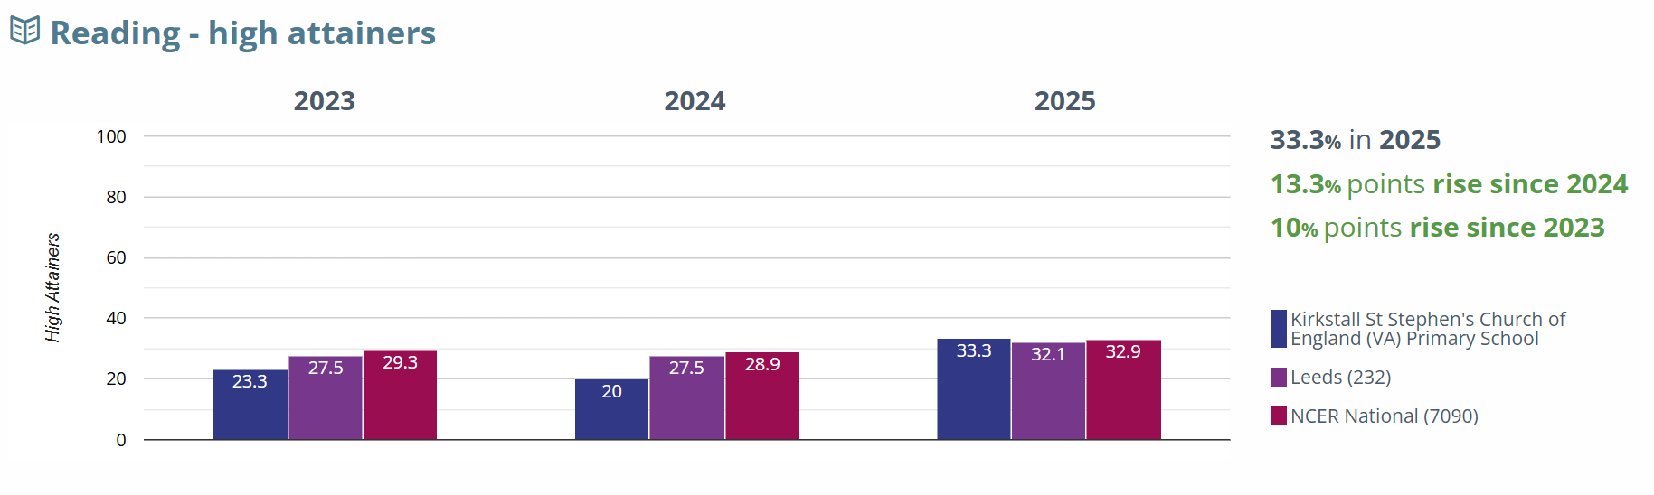
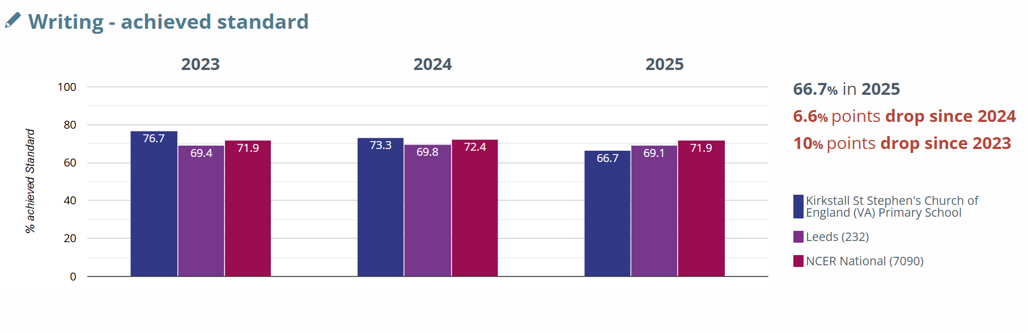
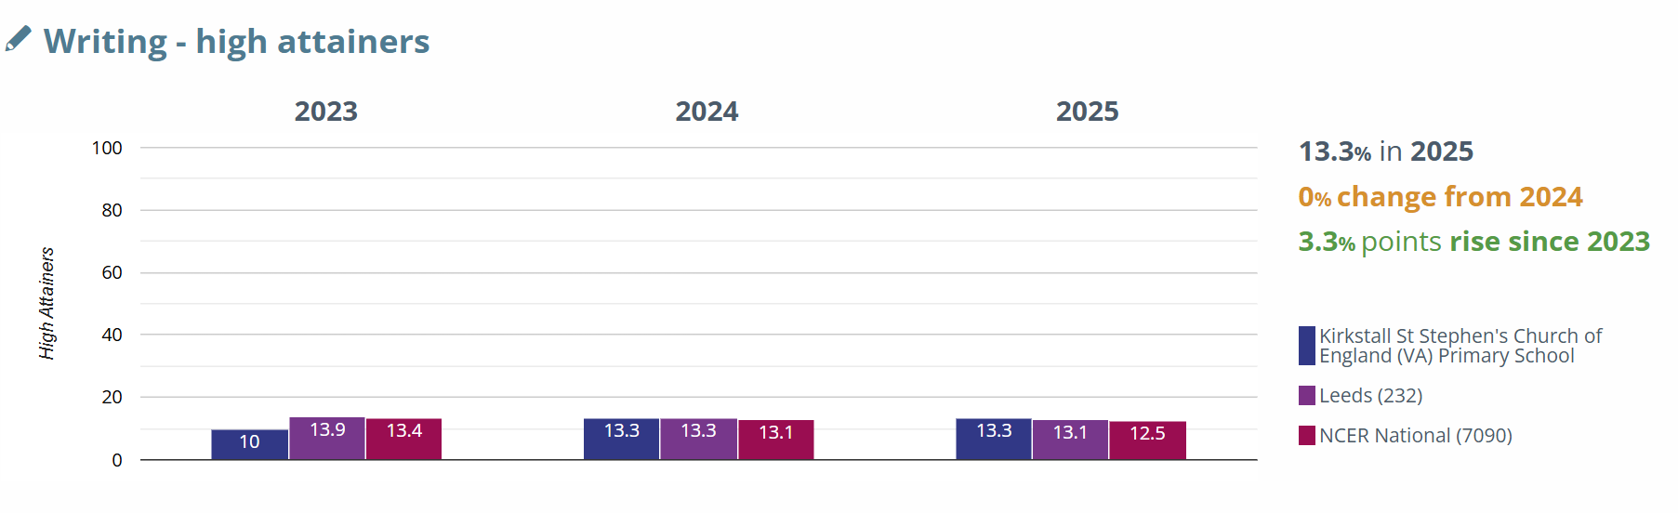
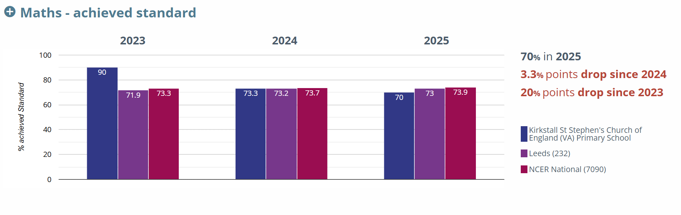
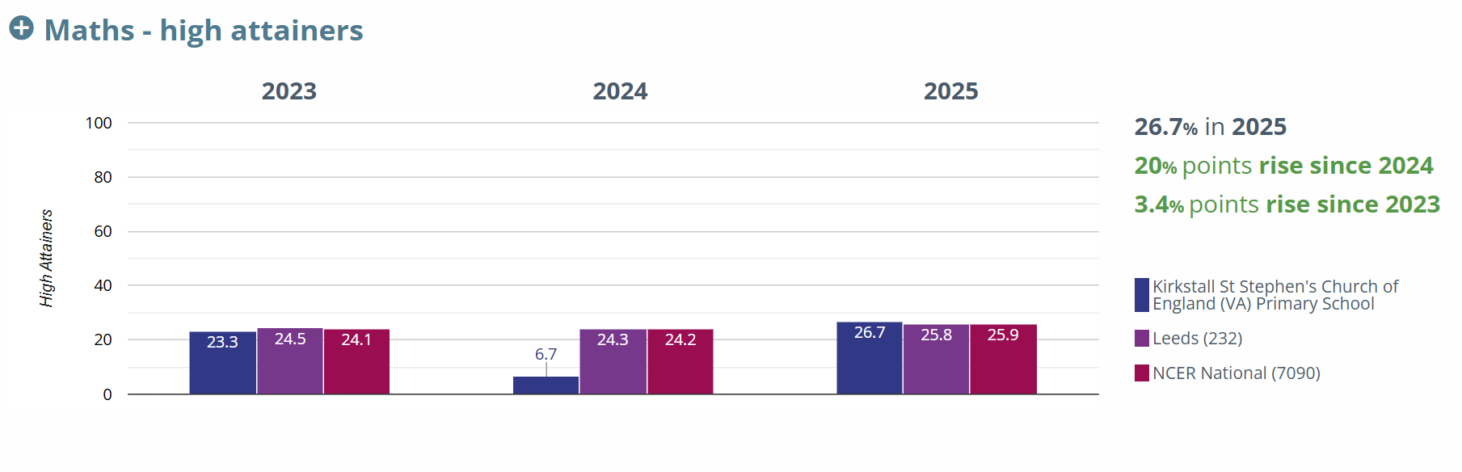
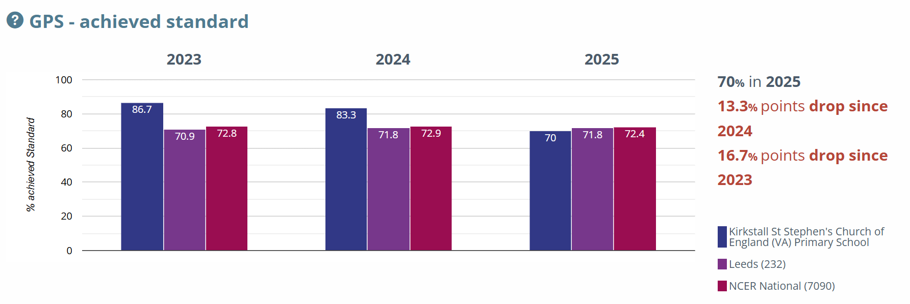
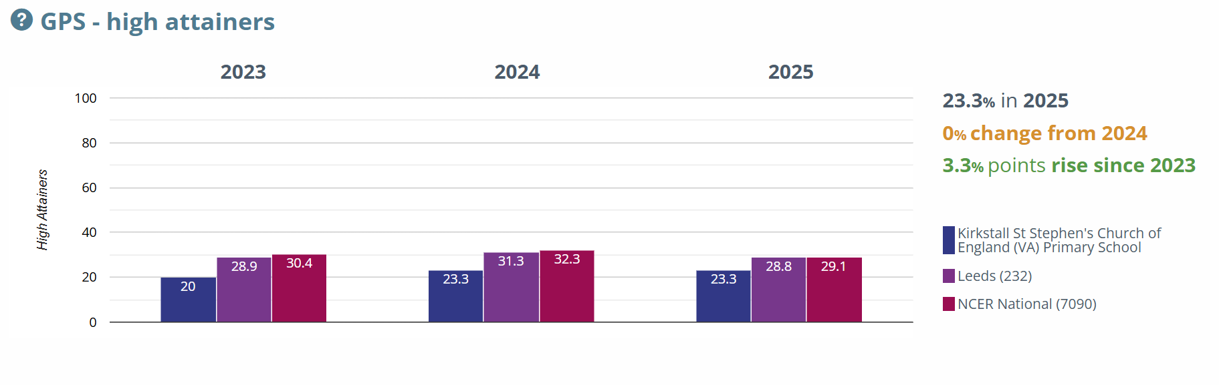GPS= Grammar, Punctuation and Spelling
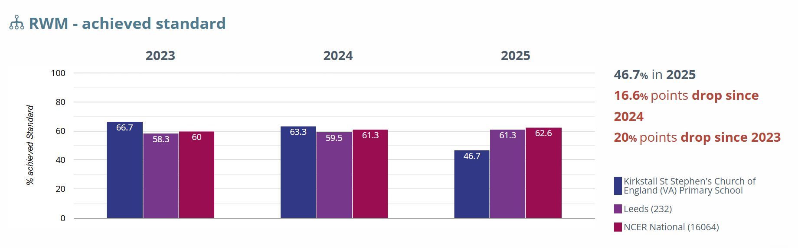
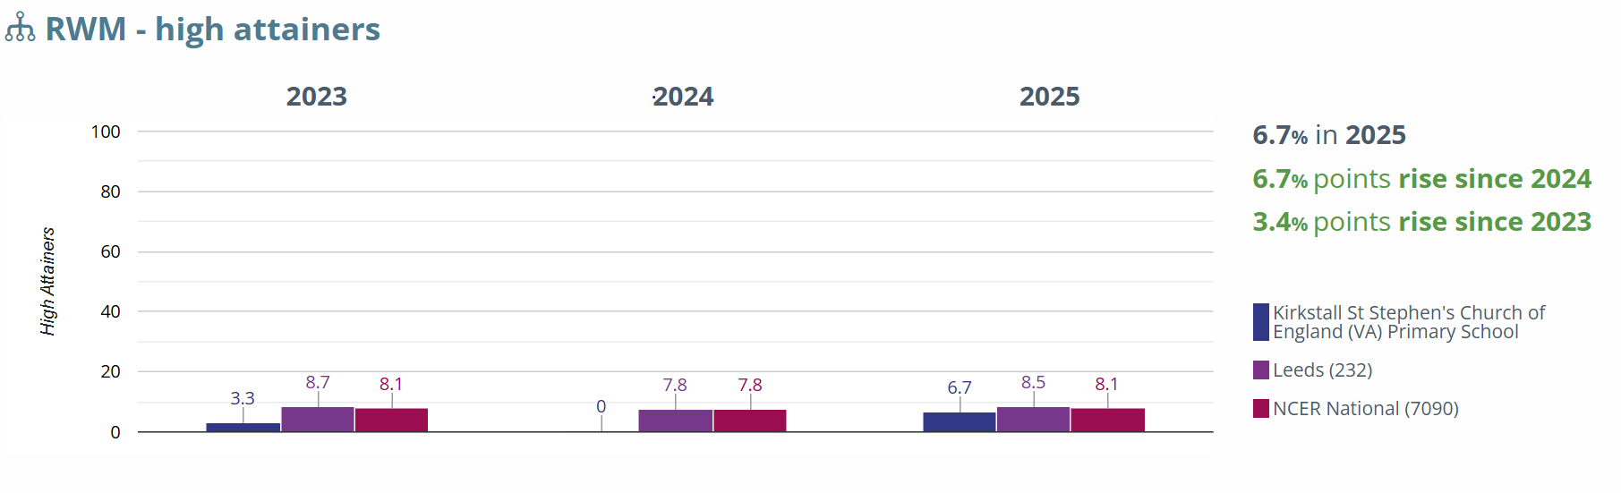RWM= Reading/Writing/Mathematics combined

