

KSS DESIGNATED SAFEGUARDING AND CHILD PROTECTION STAFF
Designated Lead for Safeguarding and Child Protection  Mr P Sheppard- Head teacher | 
Designated Officer for Safeguarding and Child Protection  Miss Zoe Barnett- Deputy Head teacher | 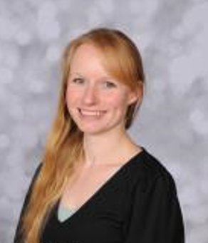
Designated Officer for Safeguarding and Child Protection  Mr S Malley- Class teacher | 
Designated Governor for Safeguarding and Child Protection  Mrs. Christine Greaves- Deputy Chair of Governors | 

